Here are some correspondence between us and our customer MOB Company. One day we got an email from J that they met with serious quality problem with the products made by a Beijing factory, and asked for our assistance in inspection. When we went to the factory, we found many quality problems, but the factory insisted that their products and factory were very good. J trusted us and required the factory to repair. Situation went worse. J would like to take legal way. But there was no required quality standard, and the sample J saw in the Fair could not be found anymore. Finally, we got a solution. To know the final solution and our comments, please read the following case.

I. J Met with Serious Quality Problem

One day, we suddenly received an email from J that they met with serious quality problem with some products manufactured by two Beijing factories. When J visited the Canton Fair, they thought some samples shown in the booth of the two Beijing factories suited their market very well, and signed a contract with the factory without any detailed quality requirement. But as the required delivery date was nearer and nearer, J found the situation was serious and required our help.

2006-4-1
Mr Tony,

Hope you are well as well as your entire staff.

I am writing to you because I have encountered a problem upon arrival.

My brother has informed me that there has been a problem with the one of the Italian suppliers of sofas.

Consequently, I have two orders effected in Guangzhou fair, which were not confirmed.

I will forward to you the proformas of the two companies.

Both companies are in Beijing, so I know there are expenses for quality control management.

Hoping this will not come as a set back to you,

Looking forward to hearing from you,

Sincerely,

J

2006-4-3
Dear J,

Regarding the orders from BEIJING factories, Tony shows his kind will to help you on this because of our close friendship.

For the expenses of inspection in BEIJING, we will not charge you for extra money for this, except the transportation and accommodation fee we cost during the trip (we will show you the invoice for every expense we used). That means you still pay us 5% of the total value of the orders as commission.

Looking forward to your early reply!

Best regards,
Celia

II. Quality Problems

Then we began to require the factory to send us drawings, leather samples and other necessary material to confirm the quality standard. But the Beijing factory was not so cooperative. Finally we got all the information and our QC manager Summer went the factory to inspect. We found many quality problems, but the factory thought we were over-strict. We took pictures and reported the problems to J, he thought we were right and required the factory to repair. The factory insisted that the product quality was the same with the sample J saw in the Canton Fair. But J thought the sample was very good, but the products were not OK.

2006-4-17
> Dear Amanda/ Linda,
>
> Based on our talk last Friday, you agreed to send me photos to show the products in the order and express us a set of samples (leather, spring, belt and catalogues and so on) as reference for our inspection. But until today, no photo is given to me, not to mention the sample.
>
> As MOB's agent, we have to do full preparation before we go BEIJING for inspection. Therefore, our boss wants to hold meeting with our QC and technical department to discuss this order before our QC go for inspection. But without any information from you, how could we do the inspection? You told me that you want us to do inspection for 60% of the goods first, since you have no space for displaying so many sofas. Could you pls send me the samples, photos and catalogue so that we could know at least what the products like and what material you use.
>
> Waiting for your early feedback!
>
> Best regards,
> Celia

2006-4-24

Dear J,

Pls see the enclosed photos from BEIJING.
The problems are as follows,

A.The leather on corners are corrugated.

B.The threads around the zips are not been cut.

C.The pin holes of sewing are too large.

D.The zips is exposed.

Factory said they wanted you to release all of these problems.

Best regards,
Celia

Dear Celia,

Thank you for your email.

The sofas I saw in the fair have very good quality.

From what I see in the photos, they are not the same quality.

Please inform them I do not release products without approval from great progress.

Looking forward to your answer,

Sincerely,
J
(The Export Director of Beijing factory wrote to J to complained Summer was overstrict.)

> Dear J,
>
> I’m Amanda, Export Director of Beijing Triumph furniture Co., LTD. Firstly I would like to say that it is very nice to have been cooperating with your esteemed company.
>
> Your agent QC Manager Summer has been working at our factory these two days. We have to say disappointedly that it is difficult on communication between us.
>
> We respect very much Summer’s hard work and professional spirit, however, we have disagreement opinion and knowledge on furniture product, so that we have divarication perspective on some problems.
>
> We don’t deny that our products have some detailed flaw, but we must understand that furniture products hardly have perfect quality; however, Summer inspects our products through a nearly perfect standard. In this case, it seemed that our products have too many problems. We definitely believe that her photos and their simple description will misguide you.
>
> At this moment, the small flaw problems are being improved or reworked, so please don’t worry about these.
>
> However, one question Summer pointed this afternoon gave us a big surprise, that is particle board can not be used. The use of particle board conforms to national regulations, and is accepted worldwide. We have been exporting many years and to most countries of EU, America, Canada, South America, Australia, East Asia and Mid East, and never have had problems with it.
>
> We deeply hope that we can communicate with you directly on these matters. Please kindly let us know your attitude.
>
>
> Best regards

Amanda

(J was Great Progress and Tony were his full trust, and thought the sample in the Canton Fair was good.)

Dear Amanda,

Thank you for your email.

I am pleased that there is cooperation between your company and my agent in China.

I have been working with Mr Tony as my agent for a long period. He has my full trust and comprehension.

All our products from China have been accompanied by Great Progress for all our suppliers, and untill today all suppliers have complied with Great Progress level of quality.

When I spoke to Mr Zhao Ming at Canton Fair, the products in the fair had a very good quality and level of excellence.

I am a little surpised at defaults mentioned by Great Progress.

I hope you can solve this little issues, in order to prepare next order of 3 containers.

Looking forward to hearing from you,

Sincerely,

J

2006-4-25 （Celia reported the quality problem Summer found during inspection to J. This was J’s reply to Celia’s email, and J’s comments were in red.）
Dear Celia,

Please see my comments in red.

Dear J

Before leaving Beijing this afternoon, Summer had a meeting with Zhaoming's factory, discussing about the problems we found and our decision. She reported Tony about the detailed situation, as well as the factory's idea. The factory has such feedback to the following problems:

1) The needle hole is too big. They say we exaggerate the problem, since Summer takes picture closely on the product, the hole seem bigger than it really is. So the factory neither accepts our suggestion nor make repair. They must repair hole.
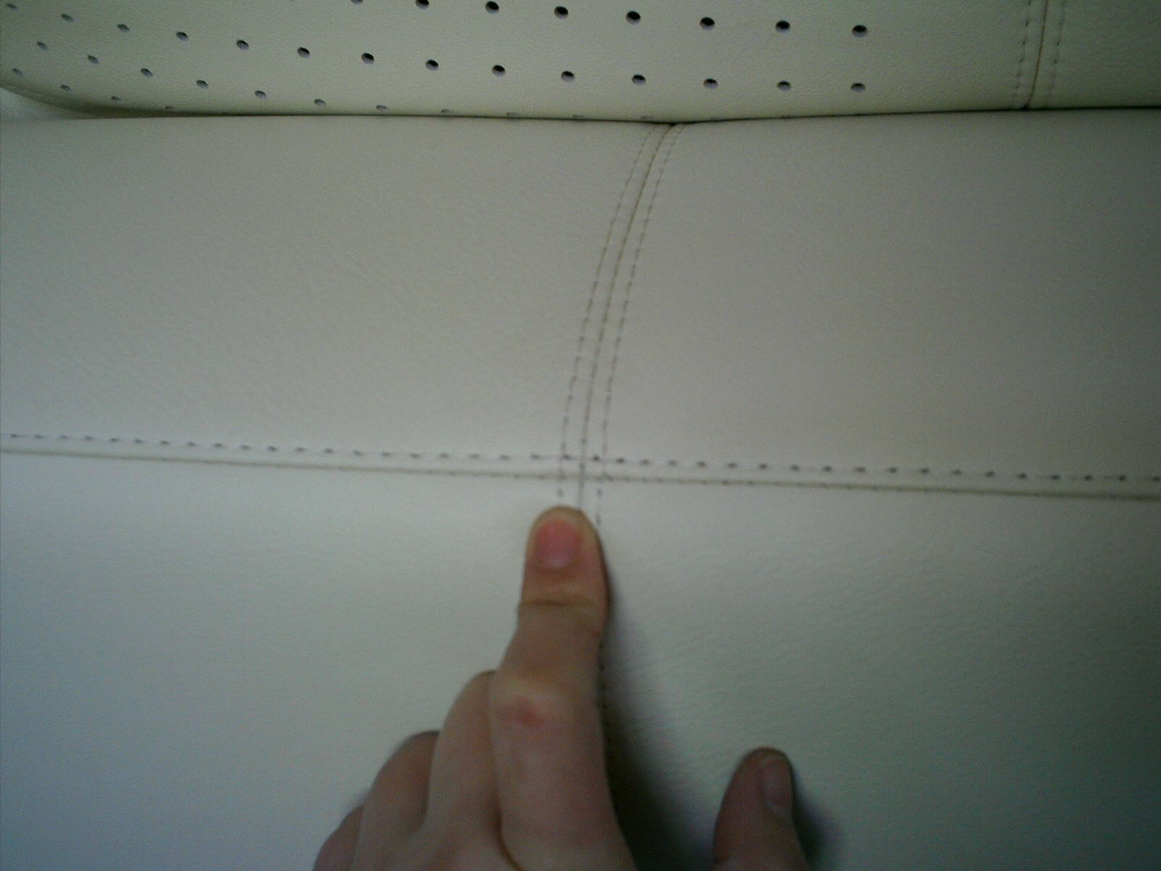

2) Regarding the flake board on sofa bottom, the factory said when you placed order you didn't clarify flakeboard was not allowed in production, you placed order only after checking their sample, you didn't issue any comment on this topic, so they don't think there is any problem for the flakeboard. One of their administrators says unless the boss of MOB required to change the material, they will only consider about this matter. Ask them to use Great Progress suggestion.

3) As to the thread line is not straight, they say we are overstrict with it. Inform them that the thread line must be straight.
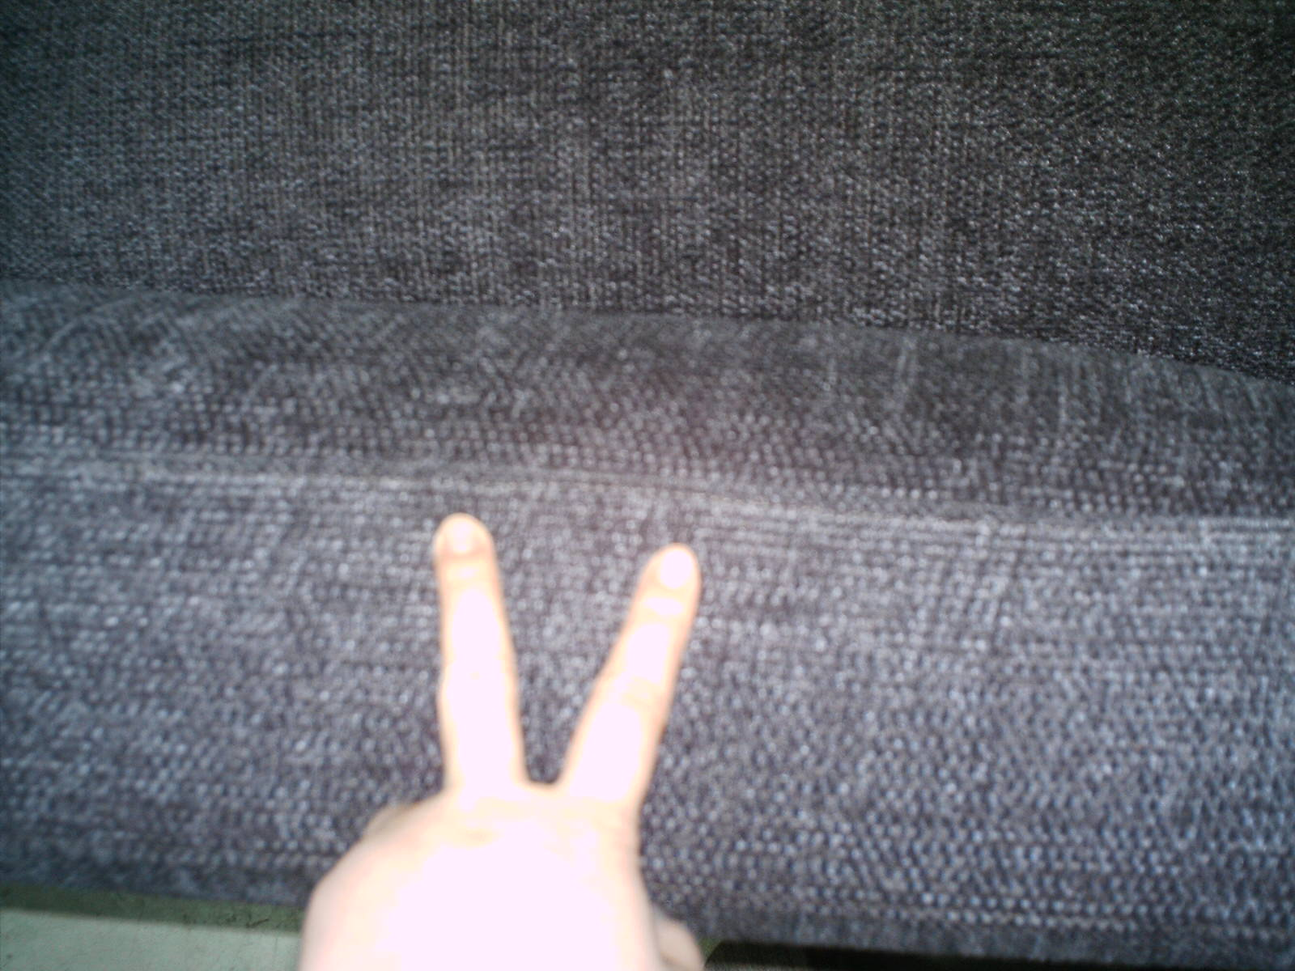

4) To the problem that there is gap on sofa wood frame and metal frame, the factory refuse our advise, they controvert it is sure to cause tolerance during processing, also the tolerance they make is belong to normal range, so the problem needn't to be repaired. I do not agree with factory.

5) The exposed nail. Yesterday they expressed they wouldn't bend the exposing nail, but today they change their saying that they actually bent all the nails in production. But Summer asked them why she still randomly found the problem, the factory kept silent. Please ask them to fix this problem.
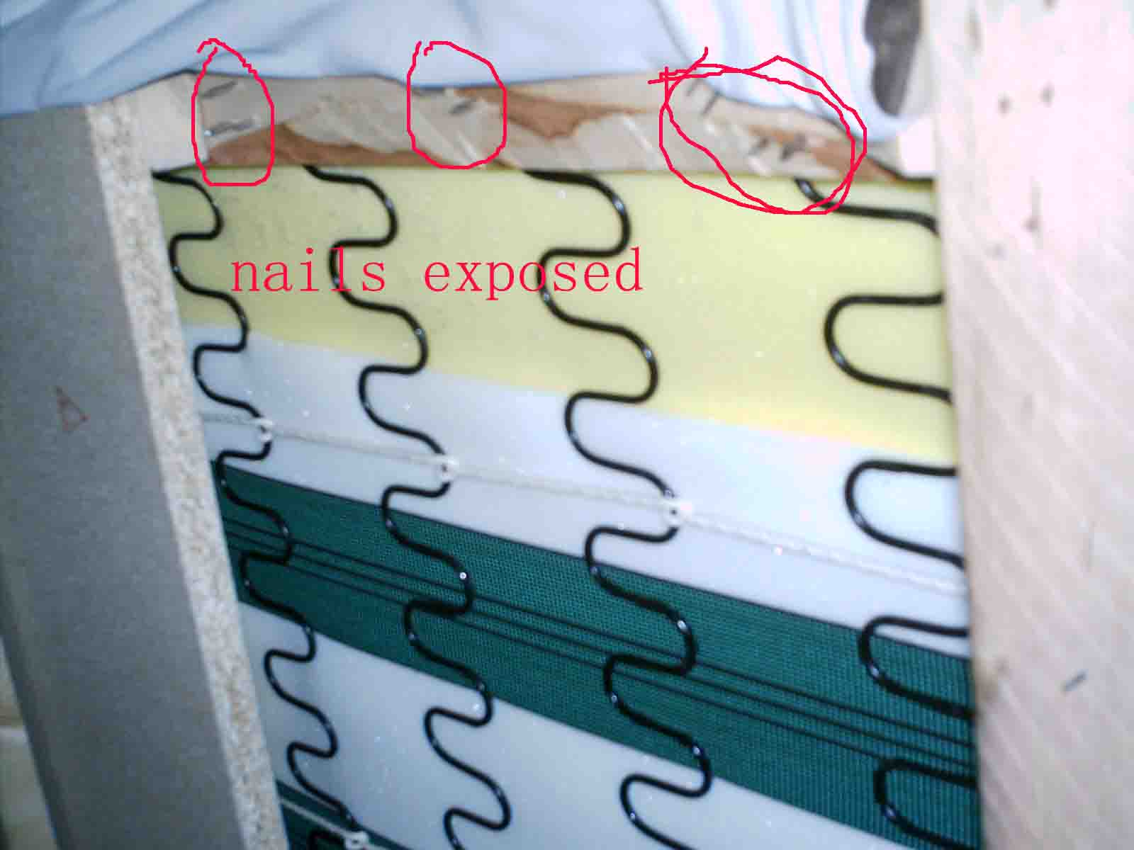

6) The leather on sofa corner wrinkles, Summer asked them for solution, they said nothing. Please ask them to fix this problem.
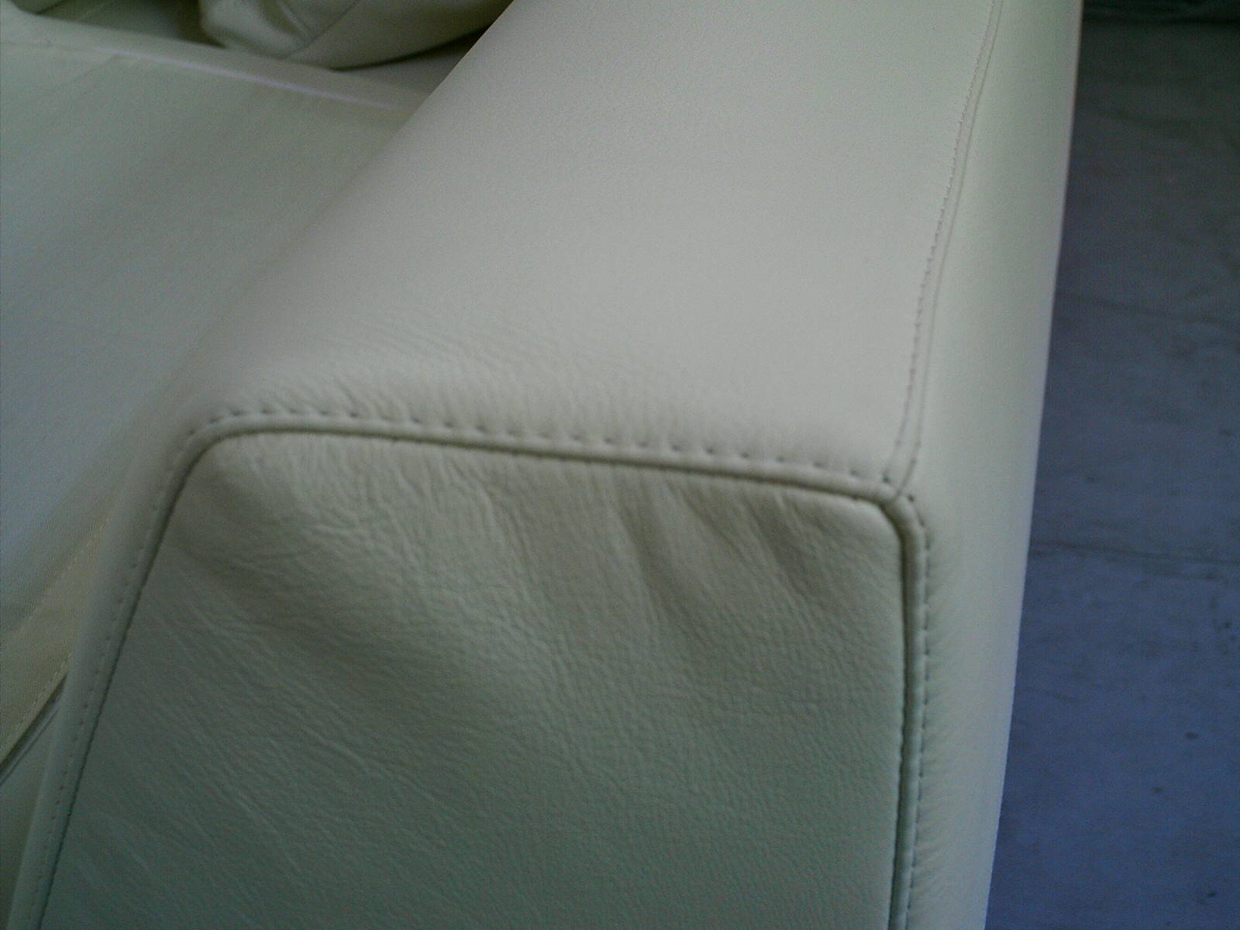

7) They had no idea on packing. I am confused. I thought this was an export company.

Their manager of international business department complained we were absolutely overstrict, he let Summer ask Tony to go to Beijing and talk with them. He considers all of the products are qualified; they are ready to be delivered. Summer tells him we do a lot of business and work a long time with you, we are clear about your requirements and standards. We have reported you about this inspection study your opinion and make the decision. If the factory disagree with us, they simply can write to you, or ask you to check the product directly. They indicate they will call Tony, but Tony hasn't received any call from them so far. Inform them that I will send 60% missing when Great Progress informs me products are in compliance with our standard.

One more thing, Summer asks them to stick your MOB aluminium logo on each product after the completion, but they say you didn't mention it when placing order, so they won't do it. I suggest they place my logo, this is if they are interested in future business.

Any comment, please let me know or call me.

Mr Zhao ming seemed to me like an understanding person. I find this situation very strange,

Best regards,
Celia
=================================================================
Dear Celia, Thank you for your email.

I will add my comments underneath.

Please inform the factory to comply with your requirements.

Their price was most expensive so they should comply. I want to continue future relation with them, because product in Canton fair looked good.

If you find difficulty for their compliance please ask Mr. Tony if I should contact a lawyer for this issue, also if it comes to it, they have my deposit, so I will require the money back with great interest on it.

Looking forward to hearing from you,

Sincerely, J
=================================================================

Dear J,

Regarding the meeting with them, still two things forget to inform you.

8) The leather pillow is not full, they say upon your request, they fill it with camlet, so it is soft and seem not full. We request them to fill more. However they don't open the pillow and let Summer check, we are not certain the filling is camlet. Please check
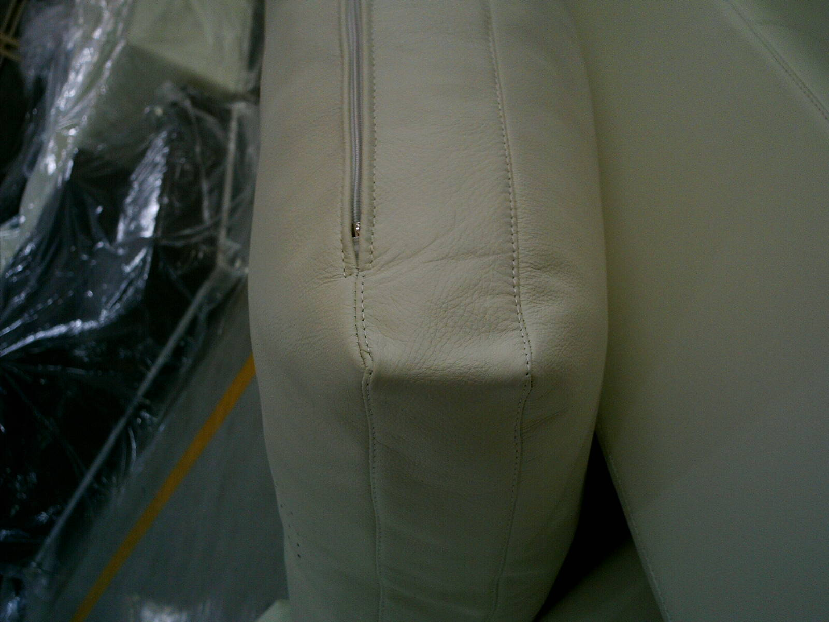

9) The seal is not straight since their zip is too rough (Mulin factory use small zip). Please fix this problem

=================================================================
2006-4-26 (Amanda insisted their company and products were good.)
> Dear J,
>
> Thanks very much for your quick response on this matter.
>
> We can definitely confirm that the products we made for you have good quality which is even better than the quality of the products displayed at the fair. We are one of the most well-know and top level upholstery sofa manufacturer in China for many years, and enjoy a good reputation among our customers both domestic and abroad. Our target is to make high-level and most excellent furniture in China, and we deeply know that details decide success, so every stuff works very hard and want to make improvements in details everyday although still not perfect.
>
> Ms. Summer inspected our products in a way like using microscope, enlarged the flaw details with exaggeration, which brought you some surprise. But we affirm you that the products we made for you have no substantially quality problem, they are good products.
>
> We are happy for you that you have a fully trusted agent, Mr. Tony. But we did have problems on communication with Ms. Summer as we don’t speak the same language on furniture manufacturing and products knowledge. We are more happy to work with your agent, and sincerely invite Mr. Tony can visit our factory and check for you himself.
>
> We cherish our business opportunity very much, and will definitely do our best, as we always do to every other customer of ours.
>
> Thanks again very much.
>
> Best regards
> Amanda

2006-4-27 (After J replied that the quality problems must be settled, we passed the J’s requirement to the factory.)

> Dear Mr. Yang, Mr. Jia, and AMANDA，
>
> HELLO！
>
> Here lists the quality problems when Summer checked the goods in your factory and the reply from our client. Pls fix very problem as he required. If you could not do it, pls tell us the reason.
>
>1) Pin holes are too large.Customer required you to fix the problem.
>
>2) Regarding particle(flake) board on the bottom of the sofa, customer needed you to listen to us and remake.
>
>3) Regarding the unstraight lines of the sofa, customer asked us to inform you that he wanted straight lines. If it is the cause of rough zips, pls change them into a fine one.
>
>4) Regarding the gap between the iron frame and wooden frame of the sofa, customer didnot agree that you said it was the tolerance. Therefore, pls fix the problem.
>
>5) Regarding, the nails exposed at the bottom, customer needed you to fix it.
>
>6) Regarding the corrugation of the leathers on sofa corners, customer needed you to fix it.
>
>7) Regarding packing, customer said you were a export factory and should know the packing for export products.
>
>8) For the flat cushion, you said the filling was camlet. If it is, pls add more in cushion. If not, you have to fill the cushion with good fiber foam.
>
>9) We were told that you would not stick the aluminium Logo on sofa. Customer replied that you would better to help him on this if you think of the future orders.
>
> Enclosed are the letters（all the reasons and solutions for quality problem have been seriously studied by Tony) we sent to customer and his reply on it. We would like to inform you that our boss Tony is the expert in furniture with a long experience in furniture manufacture and professional knowledge. All the suggestions on quality Summer raised have been discussed and studied by our boss.
>
> Pls pass this letter to your leader. Our boss Tony will call your leader and communicate with him/her for this issue within these two days. Pls leave us the contact information about your boss.
>
> Customer told us that if you could fix the problems as required and make the good with good quality, he will place more orders in your factory.Therefore, pls seriously think of the quality problems we found out at a long-term aspect and fix the problems, in order that we can have a long-term and friendly cooperation.
>
> Looking forward to your reply!
>
> Sincerely,
>

III. Repair

We required the factory to repair. Summer and Tony went to Beijing again to check the repaired products. But the factory did not repair at all, and we found even more problems. Finally the factory confessed they didn’t repair because they fell into difficulties with the skilled workers. J’d like to settle it in legal way.

Dear J,
The following is the report and photos enclosed.
Summer went to Beijing to second check the sofa on Wednesday. Tony himself also visited the factory on Thursday to better understand the situation and hoped that an agreement with factory is set up and good solution is found for the quality problems.
However, no matter workers or the boss only emphasized their famous brand and outstanding marketing. From the very beginning, none of them paid attention to the production and quality. All the problems we pointed out are slight problems. They assumed that if you come and inspect the goods, you would release the goods. Therefore, no problems should be fixed. And they stated again and again that a lot of containers have been delivering without any bad feedback.
During the second inspection, we found the problems as follows,
1) Structure:
There is one way to check whether the structure is stable enough. Uplifting one leg of the sofa ( the other one on cater-corner works as a standing point) , the whole sofa will be lifted. In this case, the structure is OK.
Tony tried to raise the legs of many pcs, but he found that after lifting one leg, the other two legs would not move. That means the wooden frame is not firm, its structure is not stable. Tony told them this problem was unacceptable. But factory did not agree with us as they found no problem in past containers.

MOB comment: Must fix this problem

> 2)There are water prints on the plywood of the wooden frame. (pls see attached photo) Factory explained,” The surface of the plywood will be distorted and extruded if they nail the dry plywood to the slats." So their workers found out a method ‘they dip the plywood and nail the slats. After drying naturally, they cover the foam and leather'.
>
> Tony reminded that it would go moldy if getting wet. Factory said Beijing was dried, no problem.
>
MOB comment: Must fix this problem

> On this issue, we suggest factory to sign an guarantee, says“ Once the sofa go moldy caused by this reason, they will take the full responsibility.”
>
> 3)Large pin holes.(see attachment) We think the top layer leather should not appear such large pin holes. Factory confessed that they had tried to improve this problem for almost one year, such as placing cloth underneath the leather and change narrow needle. So far the situation is the best they could make.
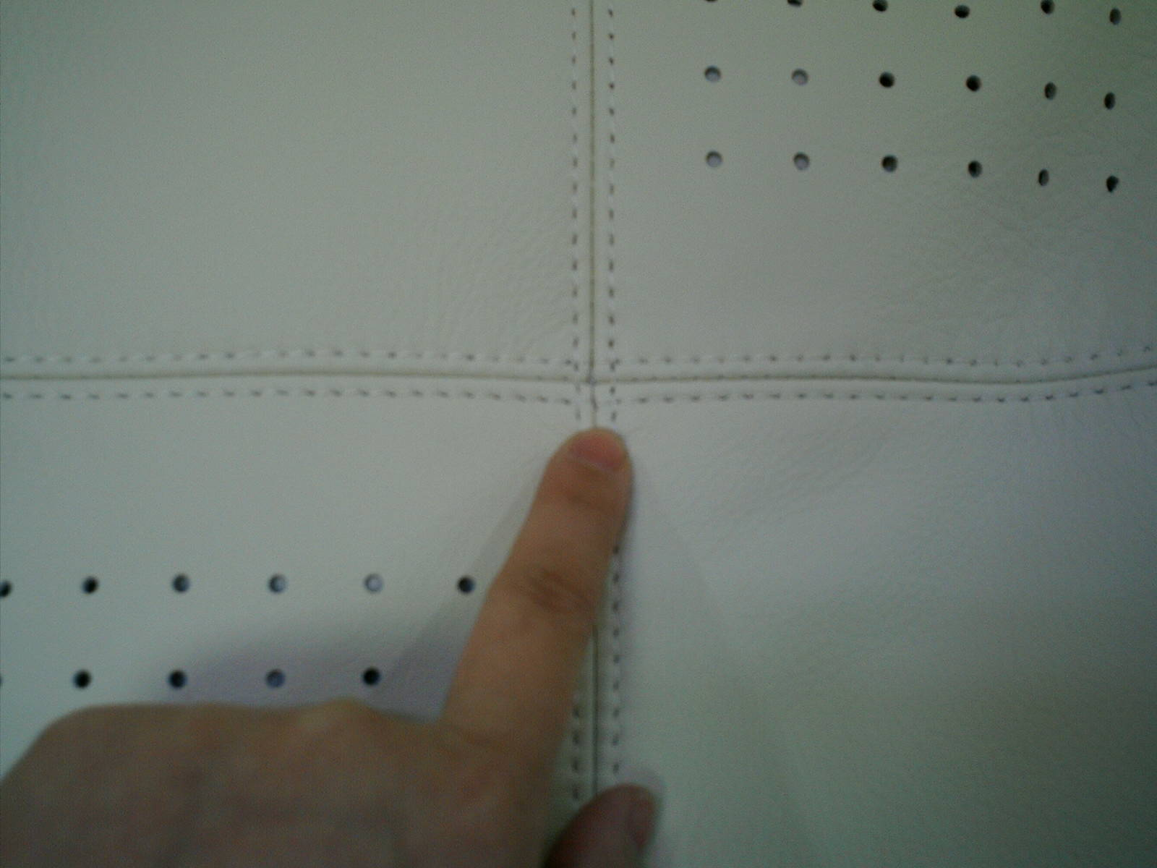
MOB comment: Must fix this problem

> 4)Leather corrugated.(see attachment) Factory replied “ The corrugated leather on the bottom of cushion, seat, side and back may be caused by using belly leather which is easy to corrugate. But they are all located in the secret place, it is unseen. ”；“The corrugated leather on front arms, side and L-shape cushion is mainly normal since the round corners and unshaped foam are the feature of their designs.” Therefore, they have no way to improve.
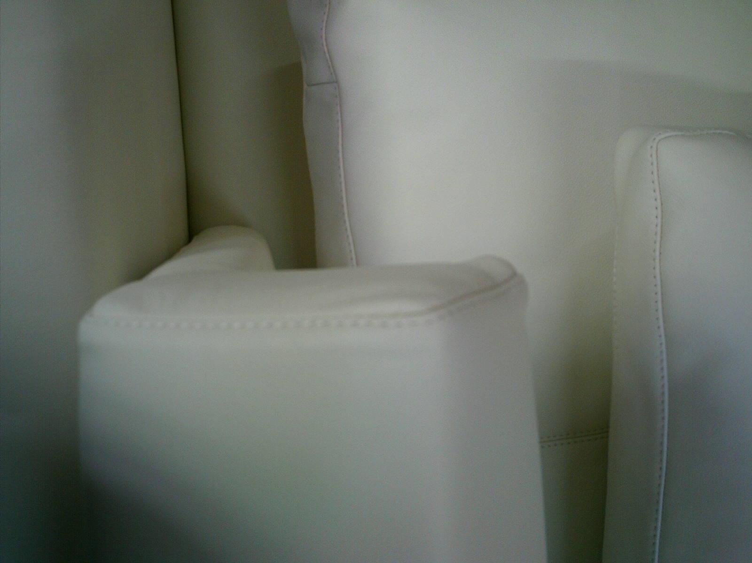
MOB comment: Must fix this problem

> 5）Zig-zag sewing and Zips are not straight.(see the attached photo). Factory argued that most of the zig-zag sewing lines and zips are located in the shelter such as the bottom of cushion and backrest. So it should be accepted.
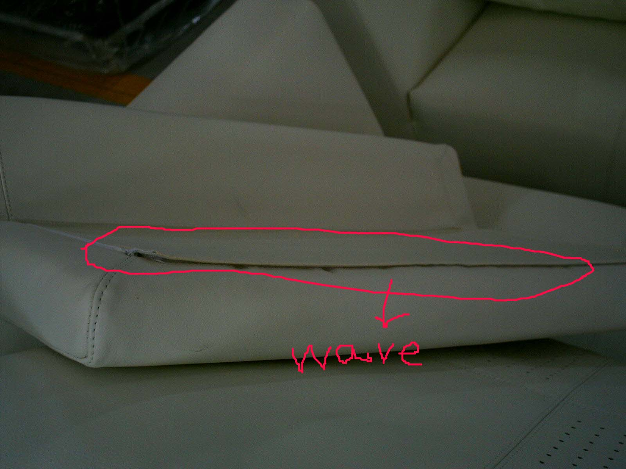
MOB comment: Must fix this problem

> 6) The two components of a suite sofa have height difference on surface. (See enclosed photo). Not only the heights are different, the arcs on corners are also not the same. (Seat and top of backrest) If the difference is within 5mm, it could be released as tolerance. But if the difference is beyond this figure, it should be fixed.
>
MOB comment: Must fix this problem

> 7) The nails at the bottom of sofa are exposed. It could be fixed by bending the sharp ends of the nails. Factory promised to fix this problem, but now they said it would not affect the structure of the sofa and would not hurt anyone since they were far from the bottom cloth, so they would not do it.
>
MOB comment: Must fix this problem

> 8) Particle board is used as the supporting board at the bottom. (See the enclosed picture).Tony saw a worker in their workshop using plywood as supporting board. Tony was told that their Taiwan customer did not allow them to use particle board.
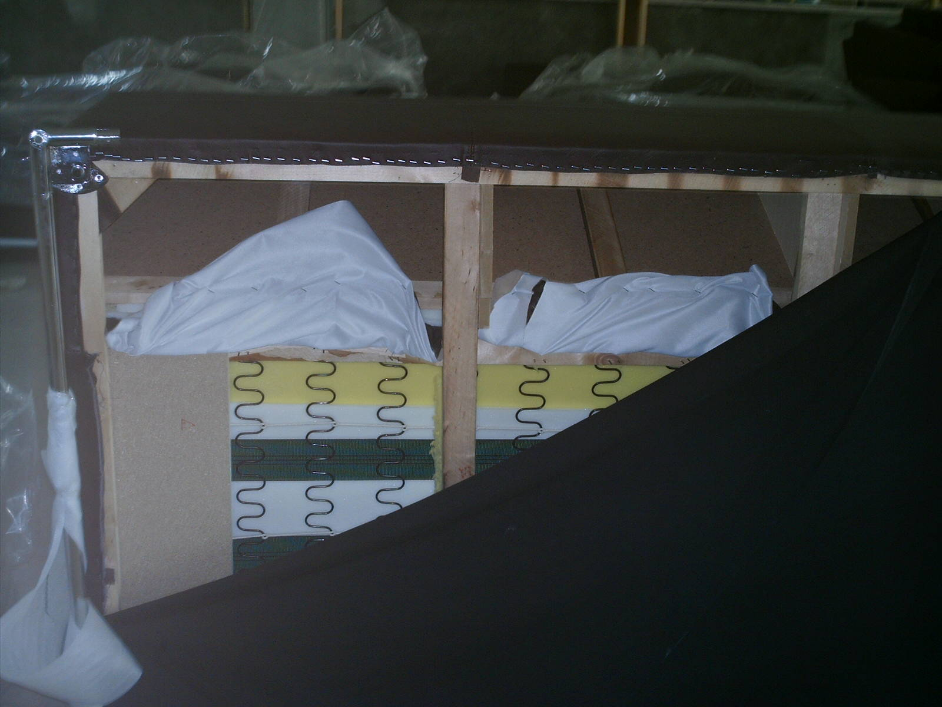
>
> 9) The legs are not locked stable. (See the photos) The sofa legs are locked through a metal panel to the sofa base. But the metal panel is not flat. This will cause the legs shaken. Tony advised them to add a rubber sheet on it and then lock. But they said it was unnecessary only if the legs were locked tightly.
>
MOB comment: Must fix this problem

> 10) Tony and Summer found that the ends of the zips were printed the name of the factory. We told them seriously that any Chinese as well as names of the factory were forbidden in your products. However, factory said as you did not mentioned this to them before, they would not change them.

MOB comment: Not acceptable

> 11) 3000 series: we found the iron frame did not attach closely with the wooden frame. Factory considered it was caused by the length tolerance of the iron frame. Since the iron frame is within the length tolerance, the problem could be accepted. Tony widened the standard and told them that only if the gaps between iron frame and wooden frame, the problem could be ignored.
>
> Even though we lower the standard, the factory is unwilling to do so.
>
> 12) The iron poles are rusted. It would be unacceptable at all. But factory said the iron frame is covered by the bottom cloth and unseen. It would not affect the function and would not break. They agreed that it was a point they needed to improve. But it is not the time to do so.
>
MOB comment: Must fix this problem
>
> 13) DECO series: The seat is not filled up with foam. When touching with hand, you feel no foam at all. Factory explained the leather DECO used was bycast leather which was quite tough. It is a problem can not be solved.
>
MOB comment: Must fix this problem

> Based on our inspection, factory confessed some difficulties they met. Now, they have a few orders which is far from enough to cultivate skillful workers. Unlike Guangdong province which has a lot of furniture factories, they are hard to find professional workers. All the workers are trained by themselves. They could not press on the workers too much. If the workers leave, they could hardly find the proper workers again.
>
> This time, Tony and Summer did not argue with them about the quality problems. Summer had count the qty of the sofas and found that 41% of the sofas are completely finished; the seat base of 43% of sofas are made, but cushions unseen, and factory said they had been put in another place; 16% of them are half done. That means they had paid for all materials and used them in your sofas. They placed all the goods in the workshop and could not do packing. Once you reject the goods, they will get much lost. Therefore, Tony thinks the best solution is not going into legal way, but let it be. You do not need to give any feedback to the factory at this moment. On the same time, we will keep consulting the professional person for better solution. But Tony also reminds you to let these sofas delivered, you might also do much concession on the quality.
>
> Looking forward to your early reply!

Dear Celia,

Thank you for your email.

Please find my comments below you r comments.

From what you tell me, I have the impression that factory is unwilling to cooperate.

Please ask Mr Tony, how much can I sue them for interest and how long would it take for me to recover money back.

I am not willing to buy such expensive products with so many problems.

Please explain to Mr Zhao Ming that I am willing to buy products with Great Progress's approval.

I do not wish legal problems, but if they continue with this , I have no choice but to go to court of law.

I do not understand this factory, They do not seem to be interested in long term relationship. Do they not understand that if they make quality products for MOB that I am willing to place new order in October 2006.

Ask Mr. Tony for his best advice on this issue.

Looking forward to your reply,

Sincerely,

J

2006-5-13
Dear Celia,

Thank you for your email.

I can see that this is going to take a while.

Please inform the factory that I will only send rest of payment when Great Progress approves my order.

Looking forward to hearing from you,

Sincerely,

J

IV. Solution

The factory will not repair the unqualified products, and insisted that their products and company were good. Then we suggested J to ask the factory for a discount for the products of lower quality. But the factory refused and bargained again and again. We’d got ready to launch a lawsuit. The sample should be the base of quality standard, but the factory just left the sample elsewhere. However, J didn’t include the quality clause into the contract, and didn’t establish detailed quality standard before mass production. Even if we went in legal way, it would be very complicated and difficult. Finally, the factory agreed to give discount, and the unqualified products were shipped to J.

> Dear J,
>
> After deep consideration, Tony gave you another suggestion on BEIJING sofa---demanding a lower price for the sofa and accepting the shipment.
>
> The following is our reason for this solution,
>
> The deposit you paid factory according to the PI you gave me should be USD25828.8. Even thought you got all the money. Even though you could get all money back, you have to pay much for the count, lawyer and his accommodation and traffic fee.
>
> Therefore, Tony gave you another choice. You ask for discount and requiring fatal problems such as structure, do some concession on some less important problems (you may need to come to Beijing to point out the problems you could release) rusted iron frame and leather corrugation fixed, and accept the shipment, if you can still sell the sofas in another way.
>
> But first you have to hold off for a while. Since you do not show any instruction, they could not sell your products to others. Since most of the material used in your sofas, they used up their money. Since we do not allow them to pack the goods, their workshop is full of your products. That will be more possible for this solution.
>
> As Amanda told us the sofa displayed in fair is even poorer than those they made for you now. But since you did not point out any of the quality problems, they considered you did not care about the quality. To this point, they are reasonable. Unlike your orders in Guangdong we can visit the factories and make everything clear before deposit paid, we knew about your order in Beijing after deposit paid, we could only do the inspection after 60% of goods had finished. If you or we can clear state everything to them, they might do according to our requirement. (As I told you yesterday, Tony was told that they used plywood as supporting board on the bottom for their Taiwan customer since they required to do so)
>
> Therefore, there are two solutions so far,
>
> Firstly, you do some concession and asked for a discount (Tony said you may get 40%-20% discount). If the sofa could be sold, we think it would be better than lawsuit.
>
> Secondly, if the above solution dose not works, lawsuit will be the last choice.
>
> Best regards,
> Celia

Dear Celia,

Thank you for your email.

I will follow Mr Tony's suggestion.

The suggestion of discount attracts me.

I will hold a few days to see their reaction. Then you can ask for discount acting in my name.

Please control problem of rusted iron frame and leather corrugation.

Looking forward to hearing from you,

Sincerely,

J

2006-5-19
Dear J,

Regarding the Zhaoming factory, we intend to write them such a letter. Pls review the following content and do revision. And of course you would better change it into your own language so that it seems realer.

What do you prefer, send it to factory yourself or we send it to factory under your name? Some key words and sentences below are hidden evidence for future lawsuit if necessary. Therefore, if you revise it, pls let us know.

The content is as follows,

I seriously and repeatedly discussed with my customer about your sofas for several days.

We found the quality problems from your sofa such as the large pin holes, corrugated leather, zip-zap lines and unreasonable structure and so on. The most serious is that all the iron frame inside the sofa is without antirust treatment, it totally does not consist with both international standard to Chinese domestic standard. I have studied Chinese National Quality Standard, your sofa are even understandable to your domestic market. You could check it through the Chinese National Quality Standard and you will know what I am saying is correct.

However, we know that if we need you to fix all the problems, you will get great lost. And even you do all the fixing, the result could not be sure as good as what we expect. We are considering about how to find a way out of it these few days.

Originally, my customer asks me for top grade sofa, now he refuses your sofas since the quality is far from his requirement. And what more terrible is he claims me for compensation, as I could not give him the suitable goods. Therefore, I have to find another customer who seeks for low quality goods.

In order to let you lost less, and to be fair to both of us, I raise the suggestions as below,

1)The rusting problem must be fixed. All rusting iron frames should be rust removed and all of the iron frames must be antirust.
2)Regarding to the leather defects like corrugation, you must fix the severe ones; the less severe and slight ones could be put aside first.
3)I hope you could do some calculation. I would be claimed compensation by my customer and your goods could only be sold to low-end market. How much discount you could offer me?
4)There is still 20% of sofas on production. Pls tell me how long they will be finished in good quality. Regarding the severe problems which must be fixed, could you pls let me know how you will do? How thick is your iron, it relates to mechanics. I have to know whether the iron frame is strong enough for supporting.

Looking forward to hearing from you.

Best regards,
Celia

Dear Celia,

Thank you for your email.

Please send letter under my name.

Looking forward to hearing form you,

Sincerely

To whom it may concern,

I seriously and repeatedly discussed with my agent about your sofas for several days.

He informed me that the quality problems from your sofa such as the large pin holes, corrugated leather, zip-zap lines and unreasonable structure and so on. The most serious is that all the iron frame inside the sofa is without antirust treatment, it totally does not consist with both international standard to Chinese domestic standard. I have studied Chinese National Quality Standard , your sofa are even understandable to your domestic market. You could check it through the Chinese National Quality Standard and you will know what I am saying is correct.

However, I know that if we need you to fix all the problems, you will get great lost. And even you do all the fixing, the result could not be sure as good as what we expect. I am considering about how to find a way out of it these few days.

Originally, I thought your sofas were high quality, but I can see that my expectations were not met.

There are several ways to solve this problem; compensation or some solutions:

In order to let you get less loss, and to be fair to both of us, I raise the suggestions as below,

1)The rusting problem must be fixed. All rusting iron frames should be rust removed and all of the iron frames must be antirust.

2)Regarding to the leather defects like corrugation, you must fix the severe ones; the less severe and slight ones could be put aside first.

3)I hope you could do some calculation. I would be claimed compensation and your goods could only be sold to low-end market. How much discount you could offer me?

4)There is still 20% of sofas on production. Pls tell me how long they will be finished in good quality. Regarding the severe problems which must be fixed, could you pls let me know how you will do? How thick is your iron, it relates to mechanics. I have to know whether the iron frame is strong enough for supporting.

Looking forward to hearing from you.

Sincerely,

J

2006-5-23 (This email was from the president of Beijing Factory to J.)
Dear Mr. J:

I am happy to have the chance to speak to you through email, but I am sad the communication is about something like this. The situation is getting funny and ridiculous, full of misunderstanding, misguiding and misjudging, leading it to a disaster for everybody. We certainly do not want to see that happen, so I hope we solve this non-problem issue in a peaceful way. First of all, please allow me to give you my feedback on your comments.

1) “Large pin holes”: I find your accusation hardly acceptable, because our job is better than the sample that your agent showed and deemed the best.
2) “Corrugated leather”: for all natural genuine leather, there is no such thing as corrugation. And it is characteristic of genuine leather to have some loosened parts in belly area, which are used in hidden and back parts of the furniture, invisible on surface and perfectly acceptable.
3) “Zigzag lines”: based on our observation, even the international top brands are not better looking than Camerich with lines, so this shouldn’t be a problem at all.
4) “Unreasonable structure”: the structure of Camerich product is a special design of our proud, which has been proved to be more comfortable and durable throughout the years. Your comment of “unreasonable” is partial and biased.
5) “Antirust treatment of iron frame”: metal frame is an upgraded form of sofa structure, giving the product times more durability. Antirust treatment is not a necessity for sofa’s durability. However, I have instructed our production people to redo it to meet your requirement. The iron is 1.6mm thick.
6) I do not agree with your claim of Camerich products for low-end market only. As a matter of fact, Camerich is very popular in high-end markets both at home and abroad.

All your products will be ready in early June, the quality is as good as always. I would like to invite you to come and see everything yourself at your earliest convenience at our expenses (for you only), and we discuss face to face in front of the products, then you will understand what I am talking about.
By the way, I have to tell you that your agent has very little experience and knowledge with high-end products. I said the same thing to them too. Please forgive me if you feel offended, but I just I cannot hide my feeling and the truth.

Best regards

President
Haijun Fu

Dear Mr Haijun Fu,

Thank you for your email. I am honored that the president has written to me.

I woul like to, once again, remind you that Mr Tony Ho is my representative and agent in China for many years now.

As he is my agent, I do not feel the need to accompany production of the orders as he is in charge of this process.

I have not started working with Mr Tony Ho recently.

Mr Tony Ho and Great Progress Company have accompanied all my orders in China and everything has worked well. In fact, before Mr Tony Ho acted as my agent, I had many problems with products.

Consequently, Mr Tony Ho and Great Progress company have my full trust.

This is the first time that I am trying to do business with you, Mr Haijun Fu.

I hope that there will be many more to come.

My company buys from Italy, Spain, China and Indonesia, and this is one the few times that I have encountered such problems between the supplier and my country agent.

I am willing to negotiate with you if you are willing to negotiate with me.

My business is capable of buying 3 40 hq containers every 3 months. I would really wish to continue a long term relationship with your company.

I hope that you will understand my position. I am sure you are a businessman just like myself.

If you find that my requirements are unable to meet, the last thing I would wish is a lawsuit.

I know that time is money and that maybe this issue would be solved, maybe in one year through the legal system.

I do not wish to go to court, but if this is the last option you give me, I will take it.

My company will not close because of USD 25,828.80

Please understand my position as a buyer.

I started this negotiation on good faith. You received 40% deposit as soon as I arrived in my country. I am sad that this negotiation has come to this point.

I hope that you can understand and that we can carry on business on a long term relationship.

Feel free to negotatiate with Mr Tony Ho on my name as he consults with me on every issue.

Looking forward to hearing from you,

Sincerely,

J

2006-5-26
Dear Mr. B:

It sounds like the problem is real serious, which I don’t think is the case. We carry good expectations to complete the first deal with you too. But if either side insists on its own opinion, it will hurt the business as well as the future cooperation. I suggest that we ship one container first for you to see the product, and the rest be kept at our warehouse for your delivery instruction. We have great confidence in our product, because we always get good comments from our customers all over the world. Your expectations for quality products from Camerich cannot go wrong.

Per your request, I tried to get in touch with Mr. Ho yesterday, but he seemed too busy to talk to me. He promised to call me back as soon as possible, so I’ll just wait.

Best regards
Haijun Fu

2006-5-29
Resend! Since you don’t give us the feedback on the 20% discount, Tony could not talk to the boss about it. Pls let us know whether you agreed on our suggestion, or you want a better discount.
Dear J,

Regarding the e-mail i sent you yesterday, we would like to know what you think about our suggestion.

All those suggestions are the results from Tony's comprehensive and thoughtful consideration.

Tony had talked with Mr. Fu on the phone yesterday. Mr.Fu said they enjoyed the reputation from all over the world. Tony asked how he could prove the comments from his customers all over the world? Mr. Fu always state that their factory is the best sofa factory in China. Tony doubted what he could show us as evidence. Tony said we could check the sofas according to the Chinese National Quality Standard (GB) terms by terms. The GB we mentioned here is the Chinese Government specified and legal standard like GS in Germany, CE in Europe. Specially the safety terms in this standard, since they have the problem of structure, they might probably be failed on this terms.

But Mr.Fu said if we had to go into the GB, all of us would only get into a” Word War". Seeing his feedback, we assume that he must know that he would not win if we inspect the goods in this way.

Looking forward to your feedback!

Best regards,
Celia

Dear Celia,

Thank you for your email.

I am sorry for the delay in answering.

I agree with 20 % discount.

Looking forward to hearing from you,

Sincerely,
J

2006-6-5
Dear J,

At the Sunday's afternoon, Mr. Fu called Tony and talked over an hour in circumlocution without raising any solution. We here let you know the main problems in conversation.

Mr. Fu showed his dissatisfaction on that we asked them to refund the deposit and asked for 20% discount, since he thought our reasons were weak. He told Tony about the poor impression of you J also. He said you were not a real businessman as you always thought yourself as God. Tony disproved him in a strong tone “ what things make you have a poor impression of J and what things let you think that J are not a businessman?”

Mr.Fu replied Tony that, J affronted his products and factory, as J said their products were unqualified. He argued that their factory would not close because of this USD24000 since they have many other big customers with a lot of money. If you keep insist, he will leave it to court.

Tony analyzed to Mr.Fu that J believed you (Mr.Fu) indeed, or else J would not pay the deposit within a short time and place order of 3 containers. If J did not trust him, you would only book a 20 feet container for trail. J dose want to do business with you. However, you failed to keep your words, you give us the products in poor quality.

Mr. Fu stated that their products were in good quality. Tony asked” You said there is not quality problem. Then how could you explain the large pin holes, unstraight sewings and corrugated leather?”

He explained that some leather they used were from cow's belly. But as these leathers are used usually in the less evident places, he did not consider this as a serious problem. Disregarding the belly leather or not, Tony said we found corrugated leather on the side of the cushion which should not be seen as less evident place. As to the large pin holes, he asked Tony what was large pin hole. He said one of their Portuguese customers came to their factory recently. They saw your products in their workshop and found good quality.

Tony said“ It is good. You can ask them to buy these products and then you refund J the money.”
Mr.Fu said the customer did not want this color. (Tony thinks that Mr. Fu is telling a lie; if what he say is true, it would be a thread to you since the sofas have sold in Portugal.)

Regarding the remedy for products, Tony told them that we did not want to fine them. We do hope they could fix the products. We suggested them to add slat to make the structure firm, paint anti-rust oil to prevent rusted and thicker the foam to make the surface smooth. However, none of this is done. But now, Mr.Fu didn’t agree that he did not remedy.

Firstly, he improved the carton labels.
Secondly, they painted anti-rust oil on the products which were not checked before.
(On the problem of rusting, Tony did not mention much since he did not want to remind them on this matter which was the fatal problem to them; But Tony think it would be impossible to do fully fixing on rusted iron frames as it needed to dismantle the whole sofa. Therefore, if they accept the percentage of the discount, you have to allow them to remove the rust on only the bottom of the sofa.)

Tony asked him to write down the remedy one problem by one problem and e-mail or fax to us, as we have to check the remedy in next inspection.

Besides, Mr.Fu argued also that they did not ship the containers on time was due to our disturbance. Tony said that your products in such poor quality, we of course would not let them delivered. It is your responsibility.

Talking about the 20% discount, Mr.Fu said this percentage is far beyond what he could accept and asked whether we would go to court if he refused this. Tony did not get back to him on this issue. Tony only asked him for his reply on this percentage of discount. Tony reminded him that the situation comes to this position:
Firstly, the person who lost most was himself. Even you do not need him to refund the deposit, he still lost much on this order.
Secondly, the quality is poor and he did not ship the containers on time. We have the full right to ask for compensation.
Thirdly, he should check the QB terms by terms and he will know what we are talking about.
Mr.Fu said the QB was only the instruction documents on letters which was not fit for practical situation.

Mr.Fu hold the phone and did not want to put it down. Tony pointed out directly that he and his admits like to do things unobjectionable which meant they did not face the actuality. Once we found out some problems, they would always refute us. Tony said he did not want to talk so much with him and wanted his YES or NO only. Tony told Mr. Fu “Although I came back from abroad, I am an Chinese. Therefore, I know you well. Pls do not fool us.”

Mr.Fu again mentioned the sample you saw in their booth was made in a hurry. The sample is even worse than those they made for you now. Since you did not point out any problem in booth, they think the products in workshop now were qualified to you. Tony asked him to show the sample, but he explained that the sample was left in Guangzhou JISheng Weibang and could not show us. Tony puzzled why such an important sample which was seen as the standard was not brought back to Beijing? It must be a disguise. Mr.Fu said that was why he wanted to ship you a container first to see the quality. But Tony said it was unacceptable at all, since you could pick the better ones and shift off the late delivery by it.

At last, Mr.Fu said what Tony told him was true and they would improve all of this in the future, but not now. He asked us to give them some time on it. Tony said the future improvement was your matter. What J wants now are the products in this order. J could not wait for your improvement in the future. Only three choices now: give us the discount; refund the deposit; fix the products.

Mr.Fu promised to get back to us on Monday on our letter. But we did not receive it yet. Once we get it, we can refute his terms one by one.

Best regards,
Celia

Dear Celia,

Thank you for your email.

I can see that Great Progress is doing a good job.

We will wait for the answer.

Looking forward to hearing from you,

Sincerely,

J

Dear Messrs. Ho and B:

I have a mixed feeling to write to you again, and that feeling is growing stronger especially after I reviewed the previous letters. The work between us is just getting started, but our opinions are going in differed ways, making me sad and happy at the same time.
The happy part is that we are dealing with a customer who got his point of view, and the sad part is that the difference between our opinions is growing bigger and bigger.
The thing itself has been clear and simple, not so terrible as MOB described. We once made two points clear: one is that Camerich is not an OEM business, it carries its own research and execution method for its techniques and products, aiming at the satisfaction of customers; the other one is a proposal of shipping one container to MOB for them to see the products, which was turned down. We did fix the problem of antirust treatment of metal frames, thanks to Mr. Ho’s job. We did also check the other disputes in question and executed necessary improvement jobs on the products. But I want to tell Mr. B that the products we manufactured for you are the same both in appearance and the inner system as the ones you saw at the fair. We don’t want one-deal business, rather we want the business to grow bigger through the truthfulness of our mutual effort. We would feel terribly bad if your expectations were not met.
I must talk about one thing here: the two cruel options you give me. I don’t understand why you force me to do that. Of course, customers are entitled to make such a demand if they are not happy with Camerich products. But I want to repeat myself: Camerich is aware that pursuit to the beauty of products is endless, and we have been working on the improvement of Camerich competitiveness. Most of the problems once in existence are under our control. We are determined to provide our customers with good products. Your selections of Camerich products match the market positioning, and I believe your order will bring you new business opportunity and development. You are working with a company of creativity, and I trust that MOB can be a good business partner.
I don’t want to escape from problems. We Chinese businessmen maintain a principle of honoring “friendship” in business. For the purpose of reaching a start point for our cooperation and showing our sincerity, we would like to give some kind of favor in price to MOB, but please don’t take it as a discount. I hope you understand my kind offer. I suggest that Mr. Ho and Mr. B make a proposal for the degree of my favor, which is going to be your last one (because the options given to me are totally out of the question, and I hope you make the proposal on the basis of establishing cooperation, one that in Chinese term “a showing of good-heartedness”). If your proposal is again not acceptable, then the issue will be forced to go into legal process. But even that, we should take “friendship” as the top principle, because lawsuit is an inevitable part of business life.
Dear Messrs. Ho and B, although some minor unpleasant things happened, I am still hoping that we become business partners and Mr. B make a visit to Beijing at a convenient time, who will be warmly welcomed.

Best regards
Mr. Haijun Fu

2006-6-16
Dear J,

Since the letter from Mr. Fu Hai Jun you forwarded to us 10 days before, they did not give us any more feedback. Mr.Fu is a cunning guy. He does not contact us on purpose to see whether we could bear the flying time. There are two reasons for his intention, Firstly, if you are urgent in selling the sofas, you will probably to release the goods. Secondly, if you worry deeply about the lost of deposit, you will concede and accept the goods.

We also drag it on due to the reasons as follows,
Firstly, the sofas are finished. He shall invent much more money than you on this order. Secondly, your sofas are displayed full in their warehouse. They could not sell them, since you can ask for the goods anytime.

We intend to send an e-mail to Mr. Fu this weekend. The main content is as below,
So far, you (the factory) have not replied us clearly to our letter. We would like to restate that you only have two choices, one is to refund all the deposit to MOB and the other one is to accept the 20% discount as J required. You’d better to give us a quick reply.

Why we did not sent the letter in an earlier date? We have the reason.
The time-dragging on both sides are actually the battle of mentality. Whether we could win is mainly based on our possibility of success in lawsuit (the last step we have to choose). If we are sure that we could win the lawsuit, we could take it as a haft and press them to concede on the discount.

To see whether we could win the lawsuit, several documents you need to show us, 1) The contract with the signature and stamp of both sides; 2) The bank receipt of the deposit showing the account information; 3) If the account is a personal account instead of the factory account, you also need to show us the letter from factory informing you to wire the money to that personal account. If it is a personal account, we can try to deduce whether they have contravened to the national law of taxation.

We will collect all the documents and send to the lawyer who is Tony’s closed friend I mentioned before. Although he is a well-known and outstanding lawyer and seldom serves for small cases, he will do Tony a favor to study the documents for you and give you the suggestion for free before the lawsuit start. If needed, he may ask you for more information. If even the lawyer is sure about the success on court, we can boldly and strongly require Mr. Fu to accept our suggestion. If it works, it must be the best way to solve the problem.

We know that you do not want to let much people know you buy products from China. Please don’t worry about it. We will be very careful and considerable on this when things go on.

Best regards,
Celia

Comments:
The main causes of the difficulties and disputes in this case are: a. there was no agreement about quality when signing the contract; b. there was no meeting before production to fix the requirement of technique. Therefore, the factory would not repair when quality problems occurred in production, and if repair, the factory had to pay for the extra labor and material.

To sum up, before production, the quality standard and techniques must be fixed, which forms the criteria of production. Then the factory will obey the criteria, and reduce the quantity of unqualified products. On one hand, the quality could be assured, on the other hand, the factory will not lose due to the extra work and material.

Some buyers would think the loss of the factory lead by extra repair is their own responsibility, and the buyers will not care. But now the factories do not bear the good conscious of quality and service, and they technology level is not good enough. For the future good production and cooperation, we must help the factory, and to gain mutual benefit between the buyers and the suppliers.

Also, we can see Great Progress’s service is not only confined to quality control. We try our best to help our buyers to harmonize all the parties. Before production, we’ll make agreement with supplier about technology, technique and quality on behalf of the buyers. During production, we will supervise whether the factory work as per the agreement. When the factory think we and the buyers are very clear about their production and technique, they would have to obey the agreed requirements.

