New Product Development

1. Customer gives us a draft of a new design only with appearance and general dimensions.
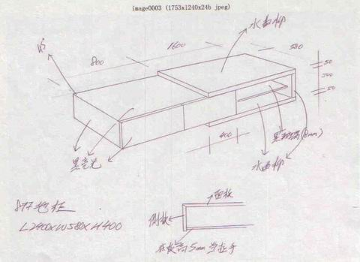
2. We study the draft and digest customer's requirements fully. Then, our engineers will work out a full set of detailed drawings including 3D drawing of the whole product, drawings of every sections, material list and PFD(production flow chart) etc. These drawings will be offered to the supplier for sample making.
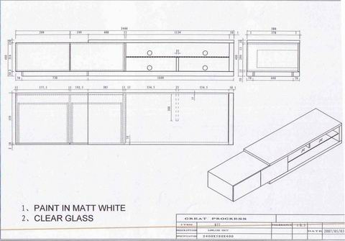
3. When half-finished sample is done, we will go to check the structure and all dimensions according to our drawings. Only if the half-finished sample has been inspected can the production be proceeded.
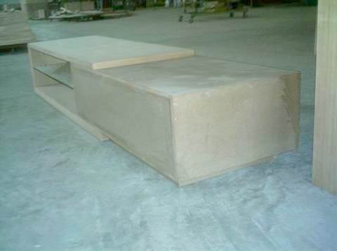
4. When sample making is finished, we will do inspection and report to our customer for confirmation of mass production.
